

CAESAR CIPER ENCRYPTION/DECRYPTION REPORT

**MAM SEHRISH KHAN**

**EMAN FATIMA** | INFORMATION SECURITY | October 20, 2025

**CAESAR CIPHER   
ENCRYPTIO/DECRYPTION WEBSITE**

**Introduction:**

The **Caesar Cipher Encryption/Decryptio**n website is a web-based application created to illustrate and put into practice the traditional Caesar Cipher encryption and decryption method. Through an interactive interface, users can input text, choose a shift value, and instantly receive the encrypted or decrypted output.

A **substitution cipher** known as the Caesar Cipher moves alphabetic letters a predetermined number of places. This straightforward cipher has historical significance and can be used to teach cryptography concepts.

**Purpose and Objectives:**

Among the primary goals are:

* To inform users about the Caesar Cipher's background and operation.
* To offer an easy-to-use interface for Caesar Cipher text encryption and decryption.
* To maintain letters' and non-alphabetic characters' case throughout the transformation process.
* To gracefully manage shift values that are positive, zero, negative, and large.
* To exhibit fundamental knowledge of HTML, CSS, and JavaScript in web development.

**REQUIRMENT ANALYSIS**

The website must have:

**Functional Requirements**

* User-friendly interface with clear navigation.
* Input for text and shift value to encrypt/decrypt.
* Preserve letter case and non-alphabet characters.
* Correctly handle all shift values with wrap-around.
* Instant client-side encryption/decryption without page reload.

**Non-Functional Requirements**

* Fast performance on client side.
* Accessibility with semantic HTML and labels.
* Cross-browser compatibility (Chrome, Firefox, Edge, Safari).
* Responsive design for various devices.
* Modular, maintainable, and well-commented code.

**Constraints**

* Supports only English alphabet (A-Z, a-z).
* No sensitive data storage or transmission.
* Avoid deprecated elements (e.g., marquee).
* Requires internet connection for background images.

**Assumptions**

* Users understand basic text input.
* Users understand shift values.
* Website used primarily for educational purposes.

**Future Enhancements**

* + Add support for more ciphers.
  + Implement input validation and error messages.
  + Improve accessibility (ARIA, screen reader support).
  + Add multilingual support.

**Website Structure and Content**

**Header and Navigation**

* The header displays the title **"Caesar Cipher Encryption/Decryption"** prominently.
* Navigation bar includes links to:
  + **Home** (About Caesar Cipher)
  + **How-It-Works** (Explanation and example)
  + **Encrypt/Decrypt** (Interactive cipher tool)



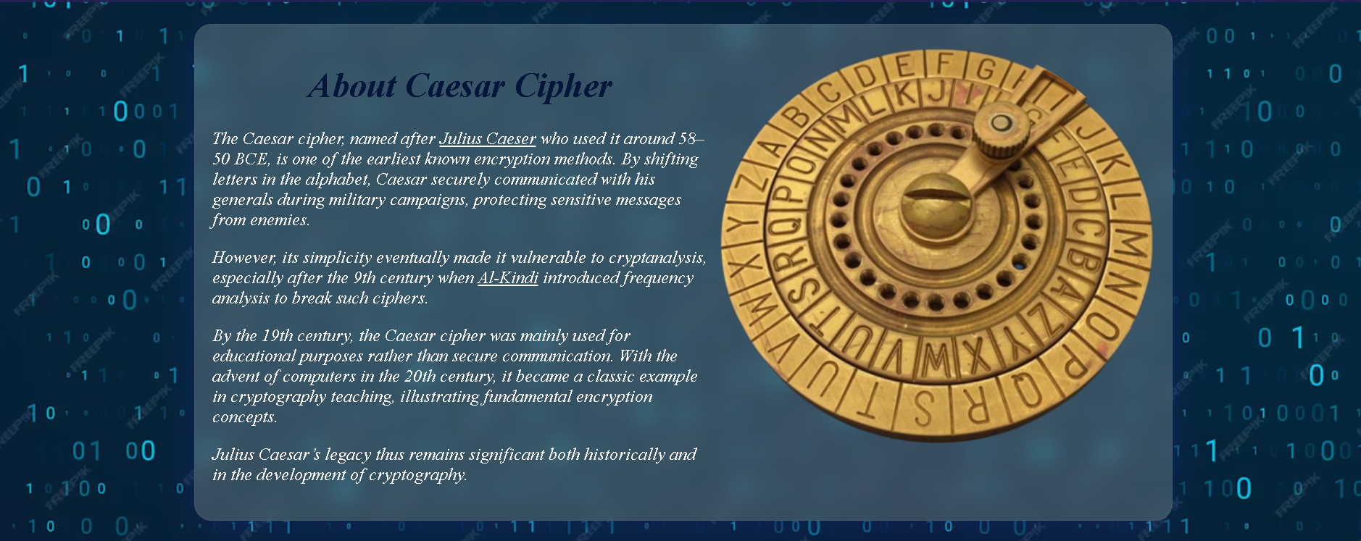**Home Page (About Caesar Cipher)**

* Provides a brief historical background on Julius Caesar and the cipher’s origins.
* Mentions key historical figures such as Al-Kindi who contributed to cryptanalysis.
* Explains the cipher’s transition from secure communication to educational use. Includes a relevant image of the Caesar Cipher wheel for visual aid.

**Scrolling text**



**How-It-Works Section**

* Explains the working principle of the Caesar Cipher.
* Details the shifting mechanism with examples (e.g., 'A' → 'D' with shift 3).
* Explains encryption and decryption processes.
* Includes a relevant illustrative image.
* Uses a marquee banner to attract attention.

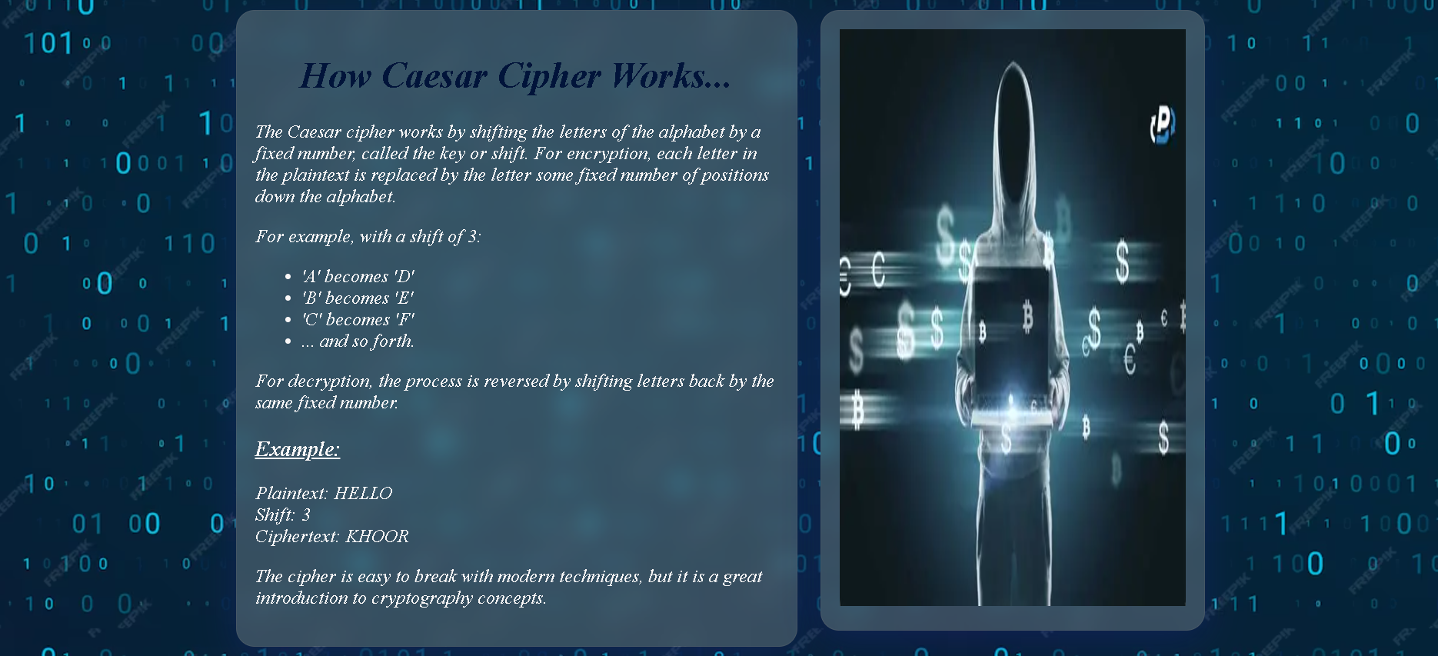

**Encrypt/Decrypt Section**

* Contains a form with:
  + **Input Text** textarea for user input.
  + **Shift Value** input (number).
  + Buttons to **Encrypt** and **Decrypt**.
  + **Output Text** textarea showing results.
* The form is styled with translucent backgrounds and shadows to look modern and readable against the background.

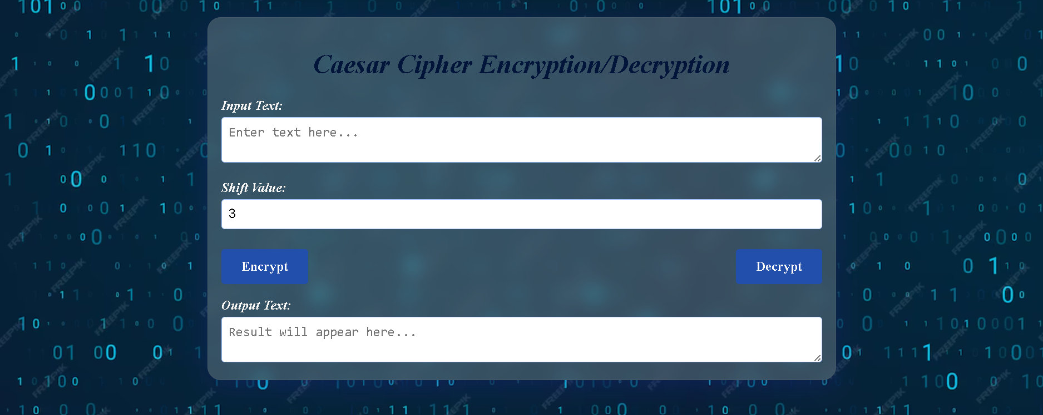

**Footer**

* Displays copyright notice.



## **Design and User Interface**

**Visual Design:**

* Background uses a digital "matrix"-style blue binary code image, creating a tech-savvy atmosphere.
* Text uses a serif font with italic style for a classic feel.
* Colors contrast well with the background for readability (light text on dark background).
* Forms have translucent backgrounds with blur effects for a modern glass-morphism style.

**Logic Design:**

The logic design consists of two basic functions:

* **Encrypt Function:** It shifts letters forward according to the given value of shift.
* **Decrypt Function:** It shifts letters backward according to the given value of shift (implemented by calling encrypt with negative shift).

Both functions iterate over each character in the input string, determine if it is uppercase or lowercase, shift accordingly using ASCII codes, and preserve non-alphabetic characters as is.

**Layout:**

* Responsive, centered content with max widths for readability.
* Flexbox used for layout in certain sections.
* Clear separation of sections with headings and spacing.

**Accessibility:**

* Labels are associated with inputs.
* Buttons are clearly labeled.
* Textareas have placeholders guiding user input.

## **JavaScript Functionality**

The function Caesar Cipher (text, shift) contains the main logic:

* The shift is normalized with the **modulo 26**.
* Iterates through each character of the input text.
* Checks if the character is an alphabetical character **(case-insensitive)**.
* It preserves case by detecting if the character is an uppercase or a lowercase letter.
* It shifts letters properly while **wrapping** around the end of the alphabet.
* Leaves **non-alphabetical** characters unchanged.

Event listeners for **Encrypt and Decrypt buttons**:

* Read input text and shift value.
* Call Caesar Cipher with a positive or negative shift accordingly.
* Display results in output text area.

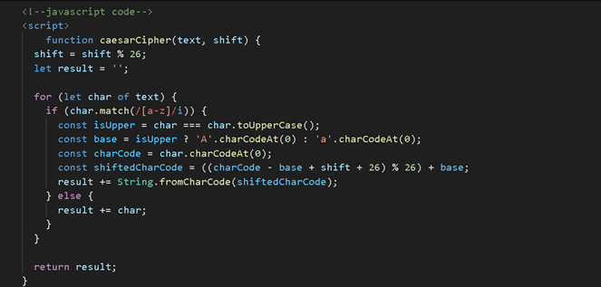

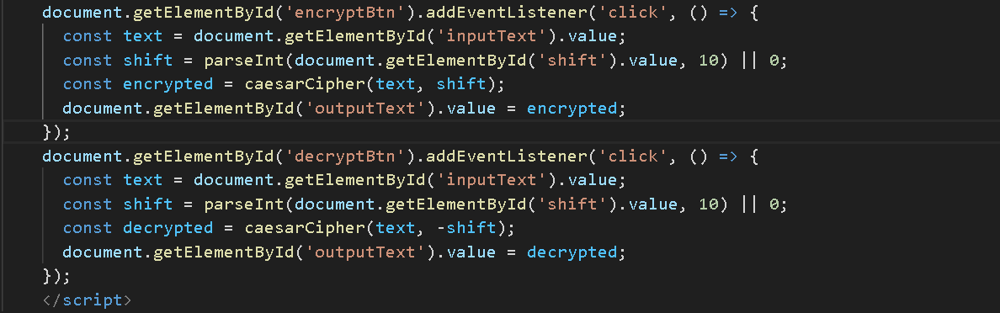

**FEatures and Benefits**

| **Features** | | **Benefits** |
| --- | --- | --- |
|  | Complete Caesar cipher encryption and decryption | Users can easily encode and decode messages |
|  | Preserves letter case and non-letter characters | Maintains original text format and readability |
|  | Supports negative and large shift values | Accurate results for all valid shift inputs |
|  | Modern design with good usability | Intuitive and pleasant user experience |
|  | Informative content on cipher history and operation | Educational value for users |
|  | Navigation sections for information and tools | Easy access to learning materials and functions |
|  | Responsive and attractive appearance | Works well on various devices and looks appealing |

## **Limitations**

* The marquee element is deprecated in modern HTML standards.
* Input validation is minimal; no warnings for invalid or empty inputs.
* Accessibility features (like ARIA labels and keyboard navigation hints) are lacking.
* No reset button to clear inputs and outputs.
* No examples or presets for common shift values.
* No copy-to-clipboard functionality for output text.

## **Testing and Validation**

**Test Case 1: Basic Encryption**

* + - * Input: "HELLO", Shift: 3
      * A screenshot of a computer

        AI-generated content may be incorrect.Output:"KHOOR"

**Basic Decryption**

* Input: "KHOOR", Shift: 3
* Output:"HELLO"

**Test Case 2**: **Wrap Around Encryption**

* Input: "XYZ", Shift: 3
* A screen shot of a computer

  AI-generated content may be incorrect.Output: "ABC”

**Wrap Around Decryption**

* Input: "ABC", Shift: 3
* 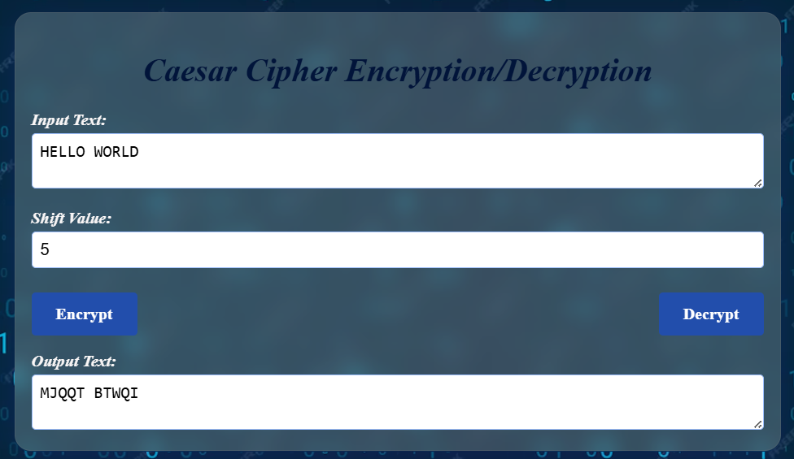Output: XYZ

**Test Case 3: Mixed Case Encryption**

* Input: "Hello World", Shift: 5
* Output: "Mjqqt Btwqi"

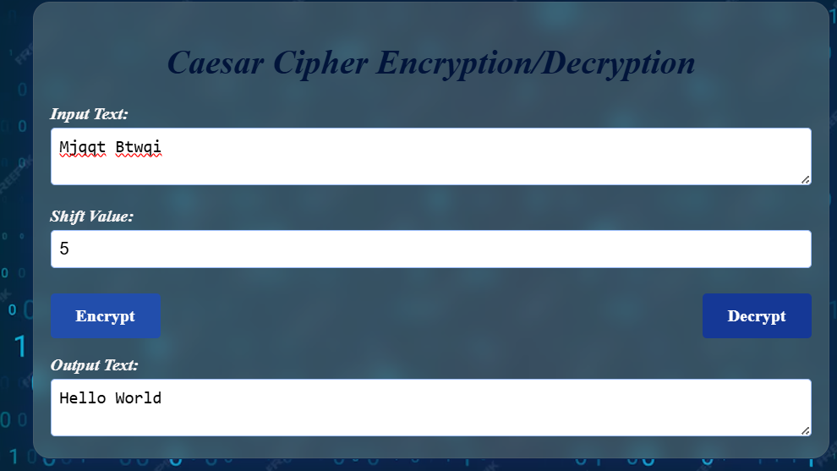

**Mixed Case Decryption**

* Input: "Miqqt Btwqi", Shift: 5
* Output: " Hello World "

**Test Case 4: Special Characters Encryption**

* + - 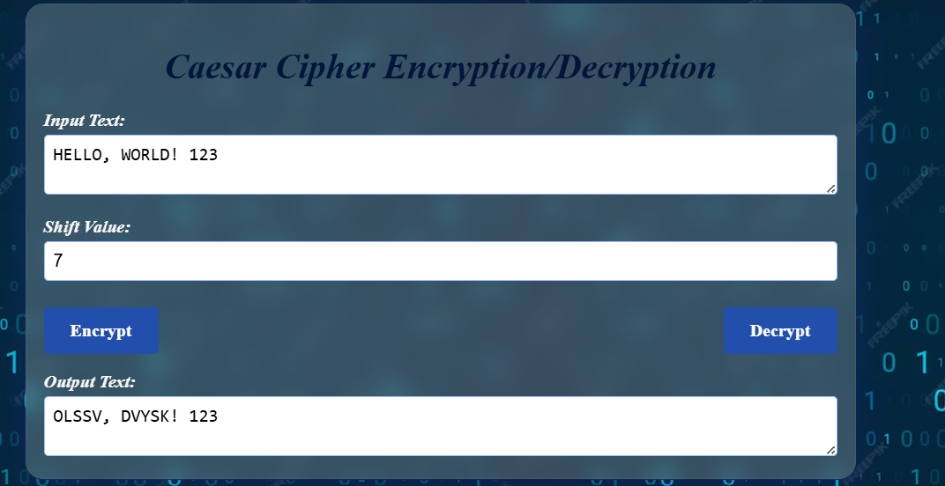Input: "Hello, World! 123", Shift: 7
    - Output: "Olssv, Dvysk! 123"

**Special Characters Decryption**

* 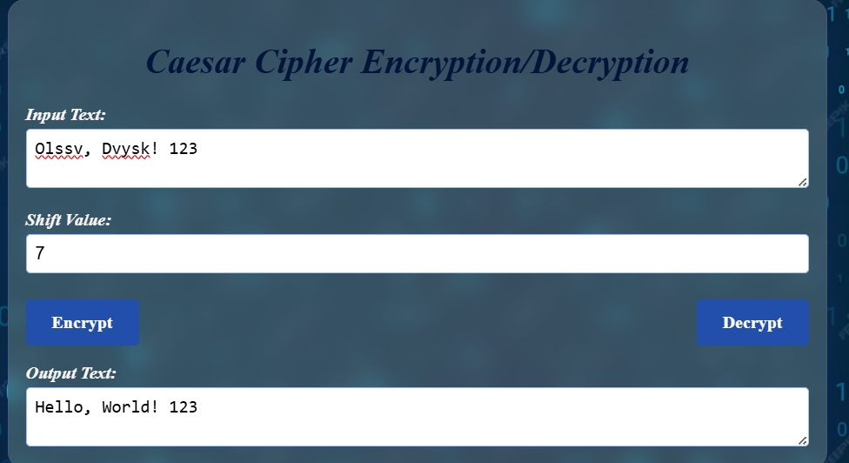Input: " Olssv, Dvysk! 123", Shift: 7
* Output: "HELLO, WORLD! 123"

**Test Case 5: Zero Shift Encryption**

* + Input: "TEST", Shift: 0
  + Output: "TEST"

**Zero Shift Decryption**

* Input: "TEST", Shift: 0
* Output: "TEST"

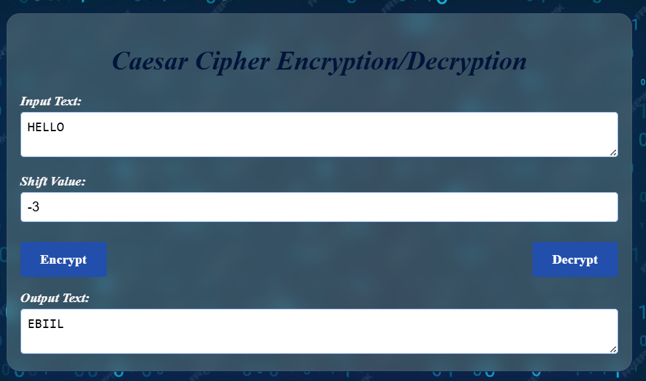

**Test Case 6: Negative Shift** **Encryption**

* Input: "HELLO", Shift: -3
* Output: "EBIIL"

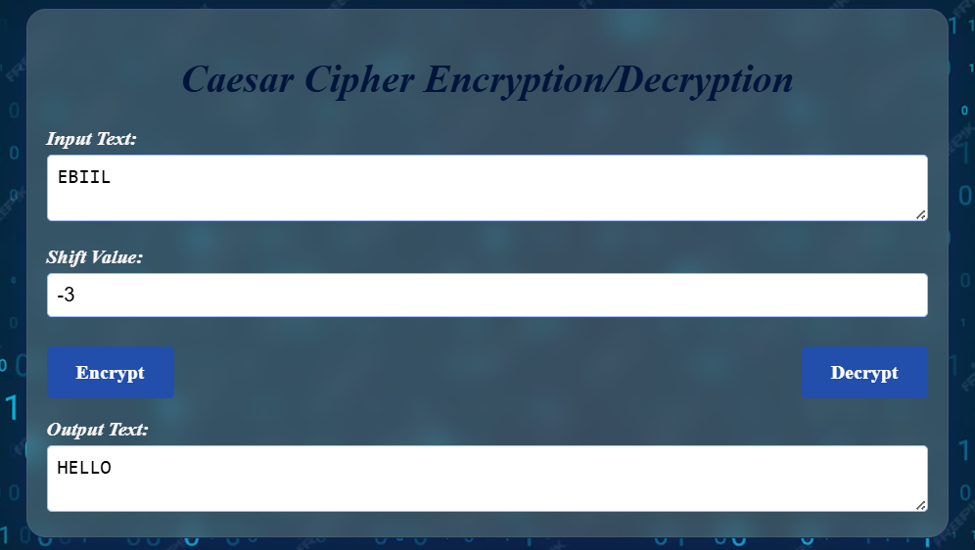

**Negative Shift** **Decryption**

* Input: "EBIIL", Shift: -3
* Output: "HELLO"

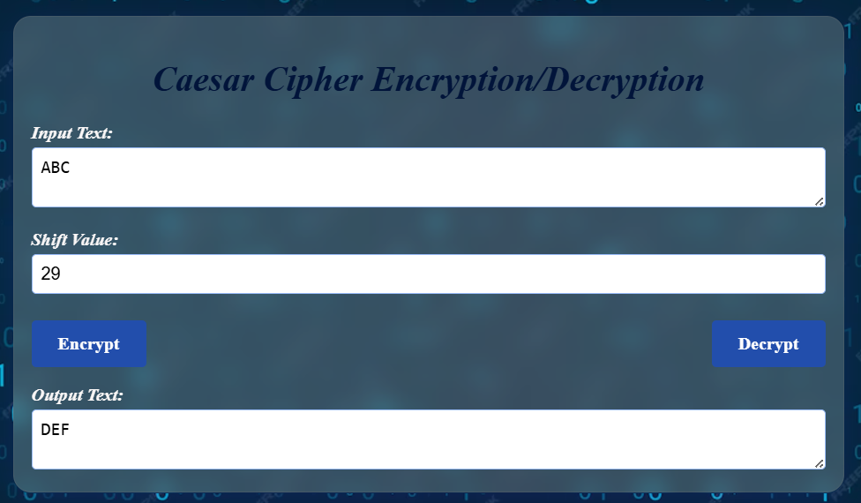**Test Case 7: Large Shift Encryption**

* Input: "ABC", Shift: 29
* Output: "DEF"

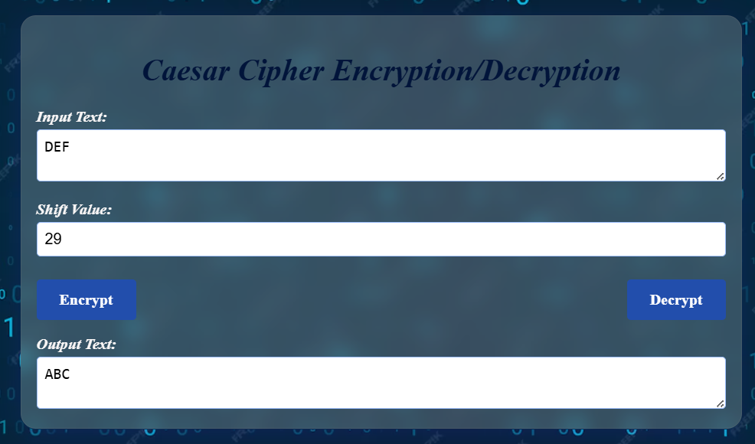

**Large Shift Decryption**

* Input: "DEF", Shift: 29
* Output: "ABC"

## **Conclusion**

This Caesar Cipher website effectively combines educational content with practical encryption/decryption functionality. It serves as a useful tool for users to learn about and experiment with the Caesar Cipher. The design is visually appealing and user-friendly, and the JavaScript implementation is clean and robust. With minor improvements in accessibility and input handling, this project would be an excellent demonstration of classical cryptography concepts in a web environment.